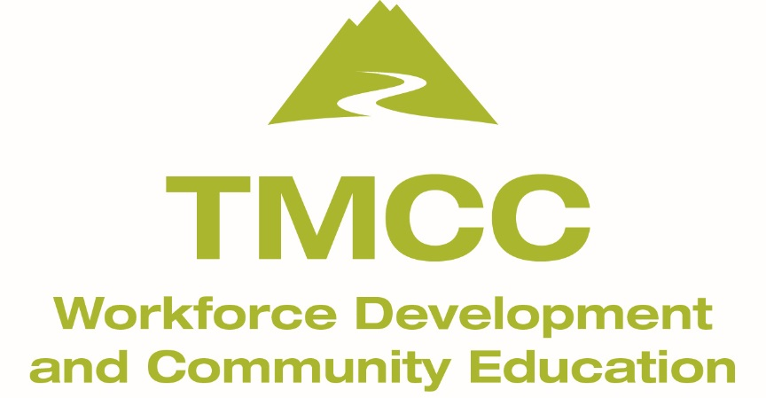

In addition to the $10 materials fee, materials required:
- Bob Ross Master Paint set
- additional colors of yellow ochre, Indian yellow and dark sienna
- three 16x20 or 18x24 canvases (Fredrix red label or Bob Ross).

Approximate total cost is $89. Or you can rent the materials from the instructor for $20 per class. All of these supplies can be purchased through the Create and Take Art Center and payment arrangements can be made by contacting the instructor.

