DRAWING: Intentional Doodling
CIRCLES, PATTERNS & LINES

List of Supplies: Please bring to class!
Sakura Micron Pen 01 size for the final drawing
Pencil
Scissors White Eraser
A smile and a willing spirit to play, explore and learn a new technique!

Supplies provided by the Instructor include:
Specialty Papers for all the class projects. Cover Stock
Pre-printed images for Drawing - Several to choose from (this is the most productive way to share the patterning process)
Plus… the Use of materials the teacher has available and on hand to share and make the Drawing experience an enjoyable one.

Drawing lined patterns in black and white with a pen is all the rage these days. The process is similar to doodling but with more intention. In class you will learn this award winning instructor’s rendition of a beautiful doodle made of circles, patterns & lines, created in a preprinted lined image of the current season. Drawing is found to be relaxing and enjoyable, helping to take the stress and worries out of your day. Plus… you will be creating some beautiful art at the same time.
http://www.varyCarol.com

Instructor: Carol Foldvary-Anderson

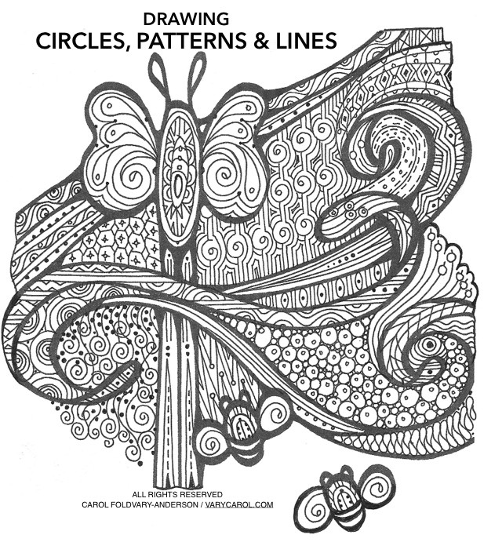

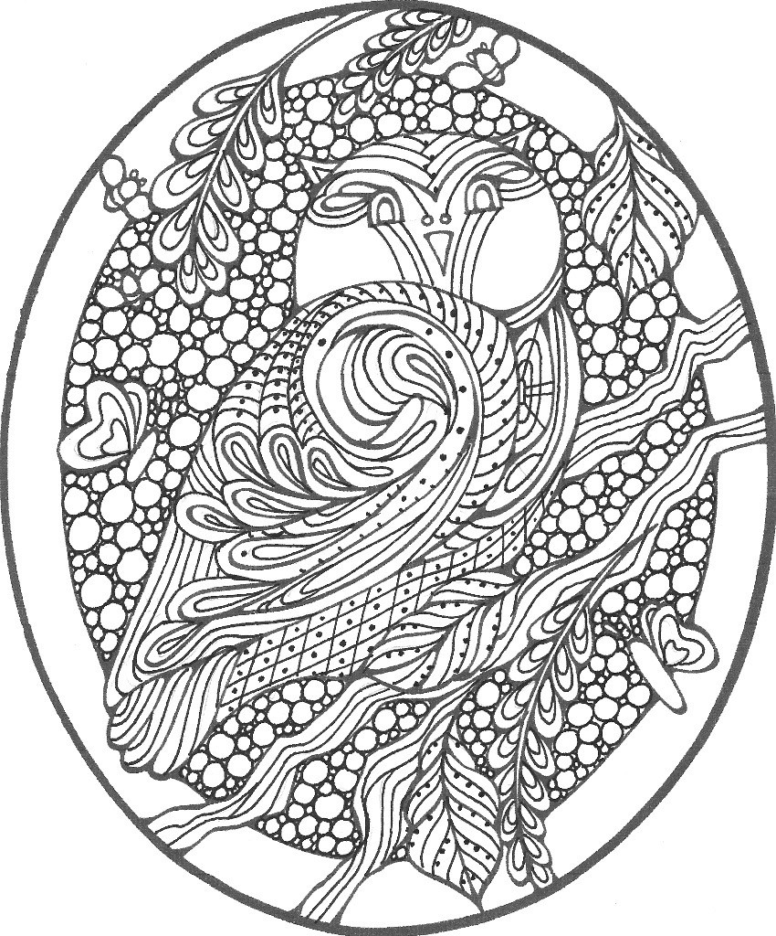
DRAWING:
Circles, Pattern’s & Lines
a more intentional Doodling technique in Drawing

RYCA OL
ARTS
C I G
I S RI
JOY!
BEAUlY!
AR IS . D SIG
CRE AT;IVE
I USTRATO
DU! CA OR
I OVATOR
AWAD I I G

