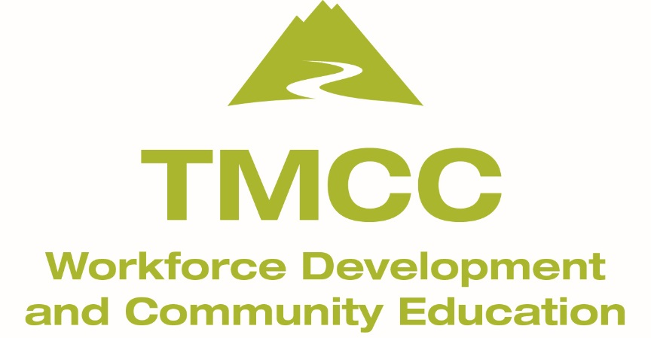

Colored Pencil Supply List

- A quality colored pencil set: 24 count preferred. Be aware that 12 count sets contain a limited selection of color choices. If you purchase a 12 count set, you will need to supplement your set with additional colors by purchasing individual colored pencils.
Below is a list of quality brands:
Prismacolor Premier
Prismacolor Verithin
Faber Castell Polychromos
Derwent Colorsoft
Koh-I-Noor Polycolor

- Paper: Strathmore ‘Bristol Vellum’ or a Strathmore ‘400 series colored pencil’ spiral drawing pad in size 9x12”
- Pencil sharpener that will accommodate the diameter of your pencils.
- Pastel Chalk Pencils
- Oil based colored pencils
- Plastic eraser

