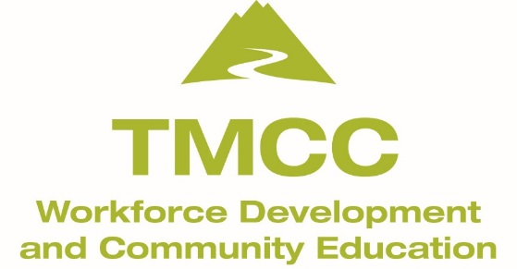

Supply List for Beginning Pastels

- Canson Mi-Tientes pastel paper: 1 sheet; medium gray/neutral is best.
- UArt sanded pastel paper: 1 sheet; it only comes in one color—buff
- Soft Pastels (NO oil pastels allowed in this class.)
For beginners, I recommend an affordable professional brand called ‘NuPastel’ made by Prismacolor. You might start with a small set of 12 or 24. If you buy the basic set of 12, you may want to buy a few extra individual colors to broaden your color choices. Most importantly, do not buy the cheap student grade packs! They don’t blend well or create rich color. (They are made with chalk and dyes which is why they are low in cost and essentially made for children.) Note: If you already own professional grade pastels, bring them. Do check that they are any of the following brands such as: Rembrandt, Daler-Rowney, Sennelier, Holbein, Unison…to name a few.
I prefer that you contact me with any questions you might have about any of the supplies. My contact phone is 775-741-2891. I look forward to our time together!

4. Artists tape, 3/4”
5. 1 pastel pencil: neutral color for sketching (vine charcoal okay)
6. Color Wheel
7. Kneaded eraser (made by Prismacolor and is the only brand that works well)
8. Foamcore board: 20 x 30” or 18 x 24” (A support to tape & secure your paper).
9. A towel for your lap to catch the pastel dust.
10. An apron or large shirt-Dress accordingly!
11. Scissors for cutting the pastel papers.
*During the 4th and final class, you may want to create a painting from your own ‘large’ photo reference.
Please bring several! ‘Large’ would be at least 5 x 7”, 8 x 10” or larger. NO smart phone images or otherwise small size photos. I’ll discuss this during one of our sessions.

Optional
-Workable (NOT final) fixative. Affordable brands: Blair or Krylon
-Tracing paper to cover your work as you transport it to and from class. Wax paper is also affordable.

Either of the below first two businesses carry all of my supplies.
www.dakotaartpastels.com Online pastel supply w/quick service.
Nevada Fine Arts Reno, NV 10% discount given to my students if you have TMCC class confirmation with you.
‘Hobby’ stores don’t carry everything on my list; employees aren’t knowledgable.
Other online companies such as Dick Blick often backorder or charge extra for quick delivery.

